Guess the word Exercise 4

# Introduction

This, unlike the previous 3 exercises, was written in a way to add a menu which is controlled using arrow keys. It currently has 3 options (SinglePlayer, MultiPlayer and Exit). I’ll talk in detail about all of them later. I used a lot of different “artistic” decisions so I could make the console look more alive and more text like. I decided on using console over GUI as I wanted to play around with making console menu and because Hangman or “Guess the word” is a text-based game so creating a GUI would make it look less astatic than console would.

# Features and Demonstrations

## Menu

One of the main features of this program is the menu. I made it in a dynamic way so the menu items can be added onto, removed and possibly even dynamically added on. 

(I used after effects to take out flickering as it would hurt your eyes)

## Game

The game itself is used from the previous exercises but is edited to fit this one and have boosted performance.

### Difficulty Selection

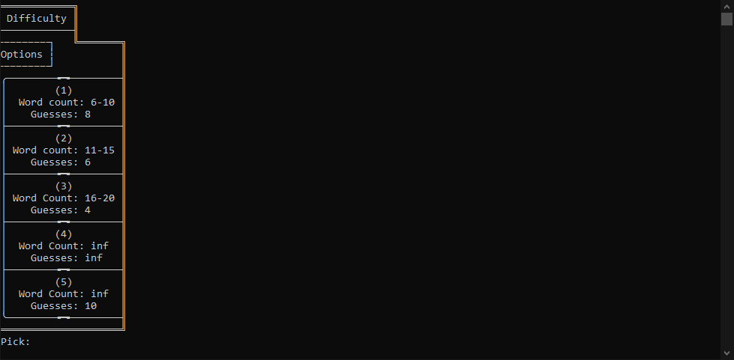

This the Difficulty Selection that shows up when you choose the game type (singleplayer or multiplayer)

### Extras

The game, once you have decided to guess or used up all guesses. Shows what you got so far to guide you on what you have to type.

## Single Game

One of the 2 game options that you can pick from is single game. This just means you play a single game and then the game ends.

## Multi Game

Multi game is just single game but it goes a couple times. You have to type in “end” to end the game and get the results

### Result table

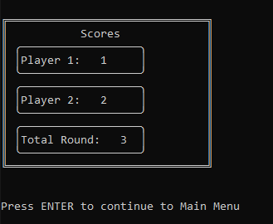Here is the result table that shows you all the wins from both sides and etc